Michael Robartes biography
Michael Robartes leads Scientific Paranormal, a paranormal investigation team in The Atlantic Paranormal Society (TAPS) Family network. A lifelong explorer of unexplained phenomena, he knows what eyewitnesses go through and helps them integrate their experiences into their worldview. Robartes lives in New York State. The Rabbit Hole Experience: On On Sasquatches, Spirits, and the People Who See Them (available in print and ebook formats) is his first book.
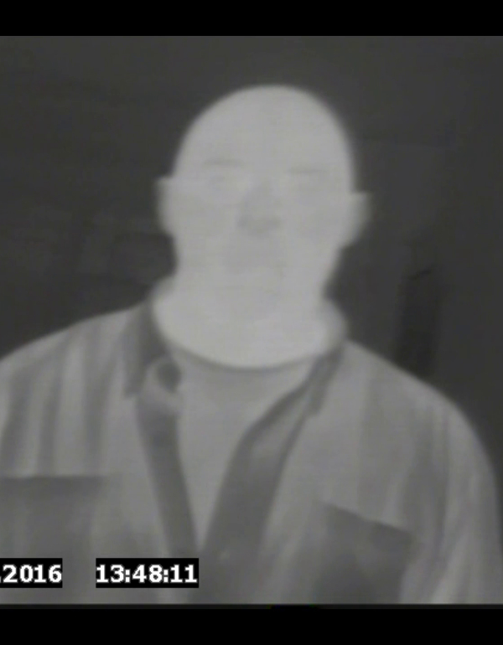
Thermal image confirming the presence of Michael Robartes at a recent night investigation.
To contact Michael Robartes, or for more information on him, co-author Paul Conroy, and The Rabbit Hole Experience, visit www.RabbitHoleExperience.com. Books can be purchased directly at www.amazon.com/dp/1939129125 or through RabbitHoleExperience.com.

